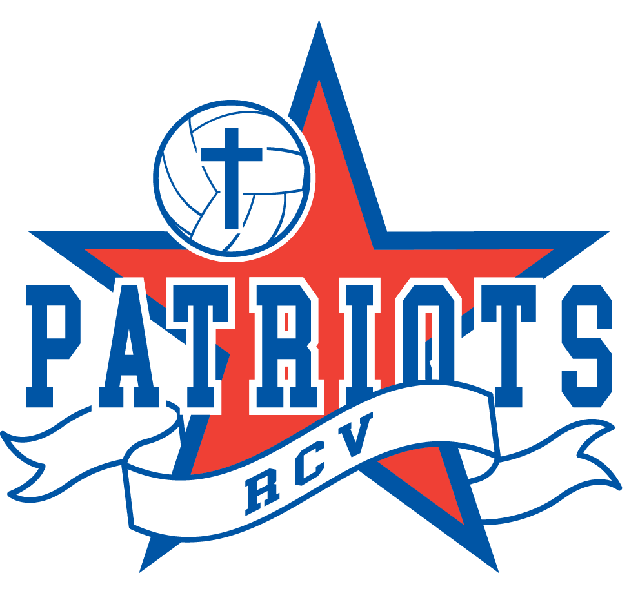
Rivertown Christian Volleyball
HSB 5625 Burlingame Ave.
Wyoming, MI 49509
rcvpatriots@gmail.com

RCV Patriots Parent Code of Conduct

As a parent of an RCV athletes(s) we depend on your support and cooperation for success for not only your athlete, but also our club. As a parent you will be expected to adhere to the following standards of behavior throughout the volleyball season.

As a parent of an RCV athlete, I hereby promise to uphold the following Parent Code of Conduct as stated below.

To honor and glorify God in all that I do:
“That the name of our Lord Jesus may be glorified in you, and you in Him, according to the grace of our God and the Lord Jesus Christ.” Thessalonians 1:12
“Whatever you do, work heartily, as for the Lord and not for men, knowing that from the Lord you will receive the inheritance as your reward. You are serving the Lord Christ.” Colossians 3:23-24

To live by the Spirit in our actions and deeds:
“But the fruit of the Spirit is love, joy, peace, patience, kindness, goodness, faithfulness, gentleness, and self-control.” Galatians 5:22
“Do nothing from selfish ambition or conceit, but in humility count others more significant than yourselves. Let each of you look not only to his own interest, but also to the interests of others.” Philippians 2:1-4

As an RCV parent I commit myself to the following:

- I will read, adhere, and commit to ensuring my athlete appreciates and maintains their RCV Athlete Code of Conduct.
- I will be positive and support my child in her individual volleyball journey.
- I will cheer in a positive manner exhibiting Christ-like behavior.
- I will encourage good sportsmanship by demonstrating positive support for all participants, coaches, and officials.
- I will drop off and pick up athletes on time for all practices and games.
- I will let the coaches coach.
- I will make sure my daughter follows the dress code policy.
- I will never approach a coach, athlete, or referee regarding a ruling on the court during a match.
- I will respect the integrity, judgment, and authority of the officials.
- I will pray and observe a 24-hour “cooling off period” before speaking with a coach over a concern, recognizing that emotions are often uncommonly high in athletes, coaches, and spectators after a game. I will also make sure my athlete has spoken with her coach first and, if there is still a need to talk with the coach, I will have a Board Member present.
- I will maintain perspective and be in control of my emotions.
- I will accept the coaches’ decisions regarding playing positions and the amount of playing time.
- I will email any questions or concerns directly to the RCV Patriots email at rcvpatriots@gmail.com so the Board may do their best to respond.
- I will support the Christ-centered activities of RCV (prayer, devotional time. and community building.)
- I will respect that tryouts and practices are closed to all spectators.
- I will volunteer for duties and responsibilities to help support the club, but if I choose not to, I understand that there will be a $100 fee per athlete.

_____________________________________________ _______________
Parent signature Date

_____________________________________________ _______________
Parent signature Date

