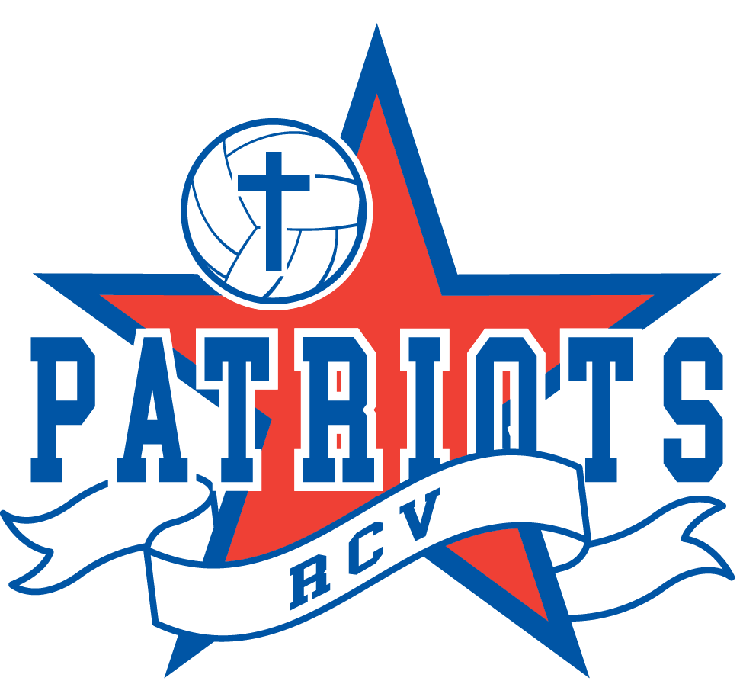
Rivertown Christian Volleyball
HSB 5625 Burlingame Ave
Wyoming, MI 49509
rcvpatriots@gmail.com

RCV Patriot’s Athlete Code of Conduct

As a part of the RCV Patriots you are expected to conduct yourself in a manner that demonstrates good sportsmanship and respect for others at all times. It is essential that you support your fellow teammates, coaches, and club to the best of your ability. As an athlete you will be expected to adhere to the following standards of behavior throughout the volleyball season.

As an athlete for RCV, I hereby promise to uphold the following Athlete Code of Conduct as stated below.

To honor and glorify God in all that I do:
“That the name of our Lord Jesus may be glorified in you, and you in Him, according to the grace of our God and the Lord Jesus Christ.” 2 Thessalonians 1:12
“Whatever you do, work heartily, as for the Lord and not for men, knowing that from the Lord you will receive the inheritance as your reward. You are serving the Lord Christ.” Colossians 3:23-24

To live by the Spirit in our actions and deeds:
“But the fruit of the Spirit is love, joy, peace, patience, kindness, goodness, faithfulness, gentleness, and self-control.” Galatians 5:22
“Do nothing from selfish ambition or conceit, but in humility count others more significant than yourselves. Let each of you look not only to his own interest, but also to the interests of others.” Philippians 2:1-4

To play without fear:
“For God gave us a spirit not of fear but of power and love and self-control.”
2 Timothy 1:7

To develop loving, encouraging peer relationships:
“Therefore encourage one another and build one another up, just as you are doing.”
1 Thessalonians 5:11
“And let us consider how to stir up one another to love and good works…”
Hebrews 10:24

As an RCV athlete I commit myself to the following:

- I will strive to honor God with my words, actions, and play.
- I will use appropriate language in appropriate tones when interacting with other athletes, coaches, officials, parents, and spectators.
- I will not taunt my opponent or be arrogant or boastful in my celebrations.
- I will arrive on time for all practices, meetings and games, with only emergencies, church activities, major family events, and illness being acceptable for tardiness or absence.
- I will communicate with my coaches regarding issues of injury, illness, or expected absence before practice either by email, phone, or in person.
- I will accept all consequences for practice and game tardiness given by the coach.
- I will communicate to my parents any necessary team information.
- I realize that glorifying God with my play requires me to care for my body with proper practice, nutrition, and rest.
- I will play by the rules of the sport, demonstrating and encouraging good sportsmanship, both in victory and defeat.
- I will not leave the game site without seeking to shake the hand of (or wave to) my opponent and thanking the officials.
- I will be a good steward, being respectful of the property and facilities of our home team and any other facility I visit. I will be diligent in picking up after myself.
- I will be responsible for any uniform or equipment checked out to me and will return it, washed and in the same condition I received it, in a timely manner at the conclusion of the season. Any item not returned will be charged to me at the current replacement cost.
- I will follow the RCV dress code for practices, games, tournaments, and anytime spent with members of the club, which emphasizes modesty.
- I will be honest. I will not lie, steal, or cheat.
- I will refrain from any alcohol, smoking or drug use during the RCV Patriots Club season.
- When I have a conflict with a teammate or my coach, I will wait 24 hours and then follow the principles outlined in Matthew 18:15-20. If needed, I will seek a coach or board member for assistance with the matter.
- I will do my best to improve as an athlete and a teammate. I understand that this will require me to put the team before my own personal accomplishments on the court. I will encourage my teammates at all times (on and off the court.)
- I will seek to encourage and assist my teammates in becoming better athletes and human beings.
- I will seek to glorify God with the talents He has gifted me.
- I will treat, with Biblical respect, my coaches, teammates, board members, opponents, officials, parents, and spectators.
- I will subject myself to the authorities that God has allowed to rule over me throughout this season. These authorities include my parents, my coaches, game officials, and the RCV Board.
- I will remember to have fun playing a sport that I love!

____________________________________________ _______________
Athlete signature Date

____________________________________________ _______________
Parent signature Date

